Biology Semester Final Review: Fall Semester 2014 Name_________________________________________
Unit 1: Scientific Method & Microscope
1. Define Biology:____________________________________________________________________________________
2. The ( independent, dependent ) variable is the variable that scientists change on purpose.
3. The ( independent, dependent ) variable is the variable that scientists observe, measure & record.
4. The ( independent, dependent ) variable is on the x-axis.
5. The ( independent, dependent ) variable is on the y-axis.
6. Circle the independent variable and underline the dependent variable. Then make a graph below and place the variables on the correct axes.
If I increase the amount of fertilizer, then my corn plants will grow taller.

7. T or F: In an experiment there is always a control group and an experimental group.
8. What is the purpose of having a control group?_________________________________________________________
__________________________________________________________________________________________________
9. What is the purpose of the experimental group?________________________________________________________
__________________________________________________________________________________________________
10. In the following experiment label the control group and experimental group.
In my corn experiment, one of my groups will have no fertilizer added to the soil.________
The remaining 4 groups will have 1 mg, 2mg, 3mg and 4 mg of fertilizer added.__________
11. In a controlled experiment there is only ( none, 1 , 2, many ) variable(s) changed. Why?________________________
__________________________________________________________________________________________________
12. T or F: The following is a controlled experiment: In my corn experiment I want to see if plants will grow taller if I add fertilizer and place them in a sunny location.
13. What two microscope parts are used to calculate total magnification: ____________________ + ________________
14. Calculate the total magnification for each of the objective lenses:
_________(eyepiece) x _________(low power) = ___________________total magnification
_________(eyepiece) x _________(med power) = ___________________total magnification
_________(eyepiece) x _________(high power) = ___________________total magnification
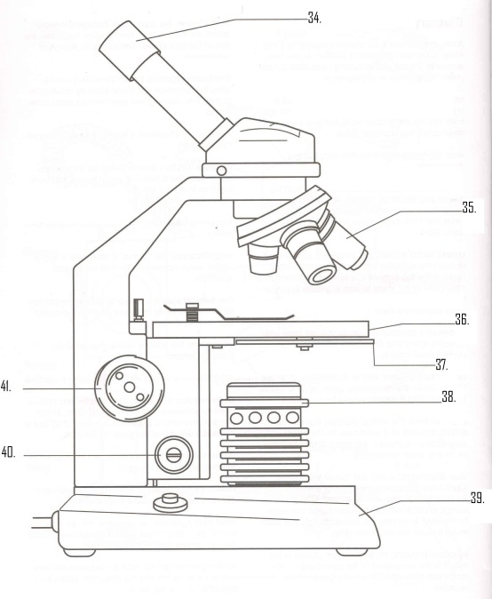
15. Label microscope parts # 34- 41 with the correct microscope part.
34.___________________________________
35.___________________________________
36.___________________________________
37.___________________________________
38.___________________________________
39.___________________________________
40.___________________________________
41.___________________________________

Unit 2: Ecology

1. The study of the interaction of living organisms with each other and their physical environment is_________________
2. T or F: Ecosystems have both abiotic and biotic factors.
3. Define abiotic____________________________________________________________________________________
4. Define biotic______________________________________________________________________________________
5. List 3 biotic factors:________________________________________________________________________________
6. List 3 abiotic factors:_______________________________________________________________________________
7. Define the following terms:
Producer:____________________________________________________________________________________
Consumer:___________________________________________________________________________________
Herbivore:___________________________________________________________________________________
Carnivore:___________________________________________________________________________________
Omnivore:___________________________________________________________________________________
Decomposer:_________________________________________________________________________________
Autotroph:__________________________________________________________________________________
Heterotroph:_________________________________________________________________________________
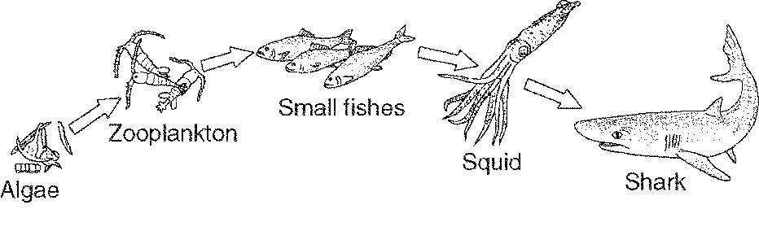
8. In the diagram above, label each organism with the appropriate term: producer, 1⁰ consumer, 2⁰ consumer, 3⁰ consumer, 4⁰ consumer.
9. In the diagram above, label each organism as a primary producer, herbivore or carnivore.
10. In the diagram above, label each organism as either an autotroph or heterotroph.
11. The squid above stalks kills and then eats the small fish. What terms from questions 8-10 describe the squid? It is a…
__________________________________________________________________________________________________
12. At the base of all ecological pyramids you will find ( producers, consumers, decomposers, scavengers )
13. Define food chain:________________________________________________________________________________
14. Define food web:_________________________________________________________________________________

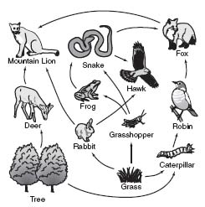
Draw a food chain from the food web on the right that starts with tree:

Tree

Draw a food chain from the food web on the right that starts with grass:

Grass

Label each organism in the “tree” food chain above with a term from question # 8.
If mountain lions were removed from the ecosystem shown due to humans killing them off, what organisms would be affected?__________________________________________________________
Explain what would happen to those organisms_____________________________________________________________________
____________________________________________________________________________________________________________
What do the arrows in the food web represent?_____________________________________________________________________
T or F: The arrows in a food web only go in one direction because energy in an ecosystem only flows in one direction.
T or F: The flow of energy in an ecosystem is always from a lower level organism to a higher level organism.

15. In an environment energy ( flows in one direction, is recycled ) and nutrients ( flow in one direction , are recycled ).
16. T or F : The water cycle, carbon cycle and nitrogen cycle all show that nutrients are recycled in the ecosystem.
17. T or F: Energy is NOT recycled in an ecosystem…it only flows in ONE direction and is usually lost as heat.
18. Circle the items that ARE recycled in an ecosystem. Underline the item that IS NOT recycled and is used up.
Carbon Nitrogen Energy Water

19. What percentage of energy goes on to each trophic level in an ecosystem ( 0%, 10%, 50%, 100% )
20. Matter can recycle through the biosphere because
a. | matter does not change into new compounds.
b. | matter can be changed into new compounds.
c. | biological systems do not use up matter, they transform it.
d. | Both b & c
21. Circle the biotic factor(s) that can affect population size in an environment.
Severe Drought Predators Limited Food Supply Disease Wildfire
22. Underline the abiotic factors that can affect population size in an environment.
Severe Drought Predators Limited Food Supply Disease Wildfire
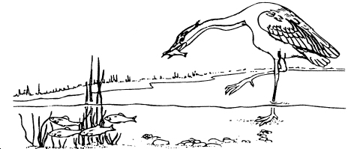
23. If the population of the bird species in the ecosystem to the right were to suddenly decrease, what would happen to the population size of :
The fish ( increase, decrease )
The grass ( increase, decrease )

T or F: The grass and fish populations would compete for resources.

24. T or F: Everything in a food web is connected in some way, so when any one organism is changed, it affects everything in the food web.
25. Define Limiting Factor:_____________________________________________________________________________
26. Define Carrying Capacity:___________________________________________________________________________
27. The things that can affect population size are known as ( limiting factors, carrying capacity)
28. The maximum amount of any one organism an ecosystem can sustain is known as ( limiting factors, carrying capacity )

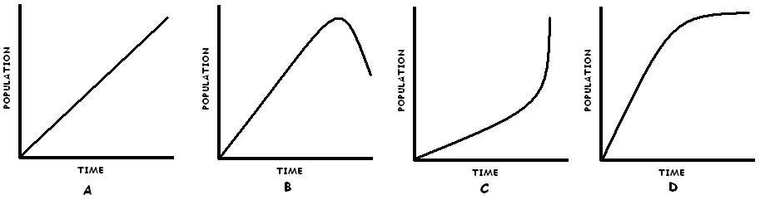

29. Which graph shows a population that is maintaining its carrying capacity?_________________________
30. Which graph shows a population that has exceeded carrying capacity and has been affected by limiting factors?_____________
31. Which graph represent human population growth?____________ What is that curve called?_____________________________
32. What do you predict will happen to graph B in the next few years (go up a bit, continue going down, go way up fast ). Explain your answer__________________________________________________________________________________________________
33. What do you predict will happen to graph C in the future? _________________________________________________________
Explain______________________________________________________________________________________________________
34. Approximately how long do we have before humans reach carrying capacity? ( 5 years, 50 years, 100 years, never will )
35. What can we (humans) do before we reach carrying capacity in order to make sure we don’t run out of resources?
1.________________________________________________________________________________
2.________________________________________________________________________________
3.________________________________________________________________________________

Unit 3: Macromolecules and Enzymes
1. The 3 macromolecules we studied are: ____________________________________________________________________
2. Which elements (from the periodic table) do carbs, proteins and lipids all have?_________________________________________
3. What is the building block of lipid:__________________________, carb:_________________________ protein:_______________
4. What foods will you find the following macromolecules in:
Protein:____________________________________________________________________________________________
Complex Carbohydrates:________________________________________________________________________________
Simple Carbohydrates:__________________________________________________________________________________
Lipids:_______________________________________________________________________________________________
5. ( Simple sugar, complex sugar, lipids, proteins ) provide quick energy…eat /drink them right before an athletic event.
6. ( Simple sugar, complex sugar, lipids, proteins ) provide energy storage.
7. ( Simple sugar, complex sugar, lipids, proteins ) provide long-lasting energy…eat them the night before an athletic event.
8. ( Simple sugar, complex sugar, lipids, proteins ) are necessary for growth and repair of body cells, muscles etc.
9. What does an enzyme do?____________________________________________________________________________________
10. The enzyme catalase found in the saliva in your mouth breaks down crackers (complex sugars) into ________________________
11. T or F: Simple sugars taste sweeter than complex sugars.
12. T or F: In a chemical reaction, enzymes can never be used up or permanently changed.
13. What can affect an enzymes ability to function? (Think back to the liver enzyme lab)
1._________________________ 2.___________________________

Unit 4: Cell Transport: (Passive Transport—Diffusion & Osmosis & Active Transport)

1. Define Diffusion:____________________________________________________________________________________________
2. Define Osmosis:_____________________________________________________________________________________________
3. Define Active Transport:______________________________________________________________________________________
In the diagram below, the X’s stand for particles that are dissolved in water. For example, X = salt particles dissolved in water. The “blank” space stands for the water the particles are in. The line dividing container A & B is a semi-permeable membrane.
X X X X X X X X X X X X | X  X X  X
3. In the diagram, which direction will the particles X move if the membrane DOES allow them to move through:
A B or A B
Explain why:________________________________________________
__________________________________________________________
This movement is an example of (osmosis, diffusion, active transport)
A B
4. In the diagram, which direction will the water molecules move if the membrane does not allow the large salt molecules through:
A B or A B
Explain why:________________________________________________________________________________________
This movement is an example of (osmosis, diffusion, active transport)
5. Which type of transport DOES NOT require energy ( passive transport, active transport )
6. T or F: The purpose of diffusion is for substances to have the equal amounts on each side of a membrane.

In the diagrams below, Solutions A, B & C have differing amounts of salt and water. The circles represent cells with membranes through which WATER can pass. Remember the goal of diffusion (in this case osmosis ) is have equal amounts on both sides of the membrane.

A.  10% salt  ____% water  50% salt  __% water |  | B.  50% salt  ____% water  50% salt  __% water |  | C.  90% salt  ____% water  50% salt  __% water
7. Write in the amount of water
In each solution and cell.

8. Which cell will shrivel
because water is leaving the
inside and going to the outside?
____________

_______________ ________________ ________________

9. Which cell will swell because water is coming inside the cell?_______________
10. In which cell will there be no movement of water because it is already equal on both sides of the membrane?_______
11. When a solution has more dissolved particles (like salt) than the inside of the cell does, it is called: ( hypertonic, hypotonic, isotonic.)
12. When a solution has less dissolved particles (like salt) than the inside of the cell does, it is called: ( hypertonic, hypotonic, isotonic)
13. When a solution has an equal amount of dissolved particles as the inside of the cell does, it is called: ( hypertonic, hypotonic, isotonic)
14. Underneath each solution, label it as: hypertonic, hypotonic, or isotonic as compared to the inside of the cell.

