MACROMOLECULE FOLDABLE
Fold and cut a piece of paper as shown below to make 4 tabs.
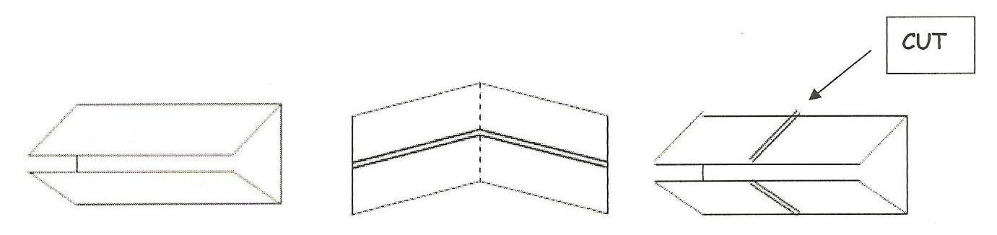
FRONT SIDE OF TABS:
Tab A
- Label the tab PROTEIN
- Sketch and color an AMINO ACID
TAB B
- Label the tab CARBOHYDRATE
- Sketch and color a molecule of GLUCOSE
TAB C
- Label the tab LIPID
- Sketch and label a TRIGLYCERIDE
TAB D
- Label the tab NUCLEIC ACID
- Sketch and color a NUCLEOTIDE

BACK SIDE OF TABS;
TAB A
- Give 4 FUNCTIONS OF PROTEINS
- List 2 EXAMPLES OF PROTEINS

TAB B
- Give 2 FUNCTIONS OF CARBOHYDRATES
- List 4 EXAMPLES OF CARBOHYDRATES
TAB C
- Give 2 FUNCTIONS OF LIPIDS
- List 4 EXAMPLES OF LIPIDS
TAB D
- Give 2 FUNCTIONS FOR NUCLEIC ACIDS
- List 2 EXAMPLES OF NUCLEIC ACIDS

ON THE INSIDE CENTER SECTION, center and write the word MACROMOLECULE
- Write the terms DEHYDRATION and HYDROLYSIS and define them.
- Draw a picture of a DEHYDRATION reaction.

ON THE BACK OF THE FOLDABLE, write your NAME and PERIOD.

