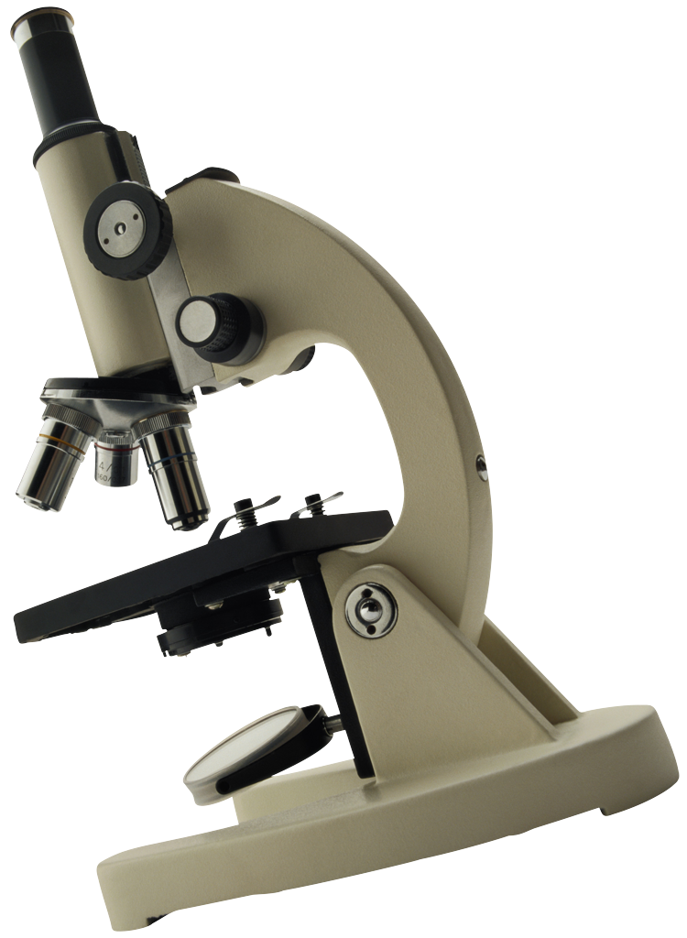
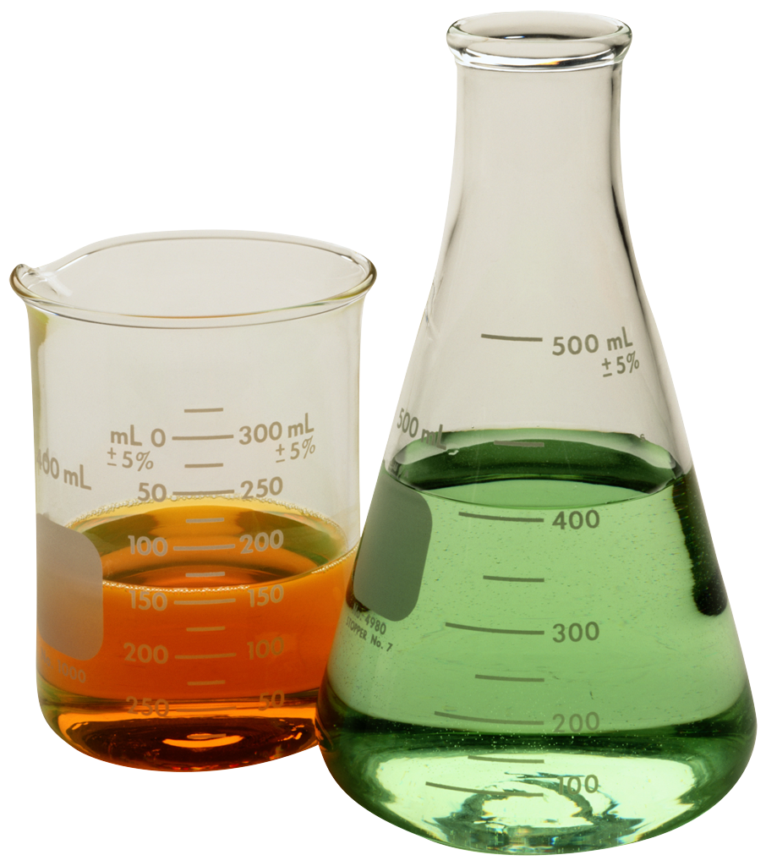
Science Laboratory Safety Procedures

Purpose
Science is a hands-on course in which you will be performing laboratory activities. Safety in the science classroom is the #1 priority for students and teachers. To ensure a safe science classroom, a list of procedures has been developed and provided to you. These rules must be followed at all times. You will take and pass, with an 80% or better, a safety quiz to ensure you know and understand these procedures. You will also sign a safety contract stating that you will abide by these safety procedures at all times. Until you pass the safety quiz with an 80% or better you will not participate in any lab activities. If at any time you choose not to follow one or more of these safety procedures, you will be removed from the lab area and be required to complete an alternate assignment. Your parent(s) will also be informed of your misconduct. You will be quizzed over these procedures on Monday, Aug. 19th.

General Rules
- Conduct yourself in a responsible manner at all times in the laboratory.
- Follow all written and verbal instructions carefully. If you do not understand a direction or part of a procedure, ask the instructor before proceeding.
- Never work without an instructor present.
- Wait until your instructor gives you permission before you touch any equipment, chemicals, or other materials in the laboratory area.
- Do not eat food, drink beverages, or chew gum in the laboratory. Do not use laboratory glassware as food containers.
- Perform only experiments that have been authorized by the teacher. Never do anything in the lab that has not been approved by your teacher or part of a pre-made lab procedure.
- Be prepared and read all procedure thoroughly before proceeding with you laboratory procedure.
- Always act mature and professional in lab. Horseplay, practical jokes, and pranks are dangerous and prohibited.
- Work areas should be kept clean and tidy at all times. Bring only your lab instructions, paper and pen/pencil with you to the lab area. All other items (ie backpacks, purses) should be left in the classroom area.
- Know the locations and operating procedures of all safety equipment. Know where the fire alarm and exits are located.
- Be alert and procedure with caution at all times in the laboratory.
- Dispose of all chemical waste in the proper contains provided by your teacher. Never pour chemicals down sink drains.
- Keep hands away from face, eyes and mouth while in the laboratory. Always wash hands thoroughly after completing your lab experiment.
- Clean all lab equipment thoroughly after use. Spray and wipe down all work surfaces. Return all clean equipment and in working order to the proper storage area.
- You will be assigned a lab station at which to work. Do not wander around the room, distract other students, or interfere with the lab experiments of others.
- Preserved biological specimens are to be treated with respect during dissection and disposed of properly when the dissection is completed.
- When working with scalpels or other sharp instruments, always carry with tips and points pointing down and away. Always cut away from your body. Never try to catch falling sharp instruments.

Clothing
- Any time chemicals, heat or glassware are used, students will wear laboratory goggles. There are no exceptions to this rule (including wearing eyeglasses in place of goggles).
- Dress properly during a lab activity. Long hair, dangling jewelry, and loose or baggy clothing are a hazard in the lab. Long hair must be tied back. Loose or baggy clothing and dangling jewelry must be secured. Shoes must completely cover the foot, no sandals allowed.

Accidents or Injuries
- Report any accident (spill, breakage, etc.) or injury (cut, burn, etc.) to the teacher immediately.
- If a chemical splashes in your eye(s) or on your skin, immediately flush with running water from the eyewash station or safety shower for at least 20 minutes. Notify the instructor immediately.

Handling Chemicals
- All chemicals in the laboratory are to be considered dangerous. Do not touch, taste, or smell any chemicals until specifically told to do so.
- Never return unused chemicals to their original bottles. Dispose of all unused chemicals in the proper container as instructed by your teacher.
- Never remove chemicals or other lab materials from the lab area.

Handling Glassware and Equipment
- Never handle broken glass with your bare hands. Use a brush and dustpan to clean up broken glass. Place broken glass in the designated broken glassware container.
- Examine glassware before each use. Never use chipped or cracked glassware. Never use dirty glassware.
- Report damaged equipment or glassware immediately. Do not use damaged equipment.
- If you do not understand how to use a piece of equipment, ask the teacher for help.
- Do not immerse hot glassware in cold water; it may shatter.

